CpathAttacher 테스트
[ INFO] [1549623118.031071375]: Distance : 10.965856
[ INFO] [1549623118.031294308]: Dubins
[ INFO] [1549623118.031304797]: LOOP
[ INFO] [1549623118.031314455]: end Pose : p: (0, 0) theta: 0
[ INFO] [1549623118.031320712]: end Pose : p: (0.5, 0) theta: 0

...

[ INFO] [1549623118.047323834]: LOOP
[ INFO] [1549623118.047328680]: end Pose : p: (7.96897, 7.98291) theta: 0.507085
[ INFO] [1549623118.047334145]: end Pose : p: (8, 8) theta: 0.5
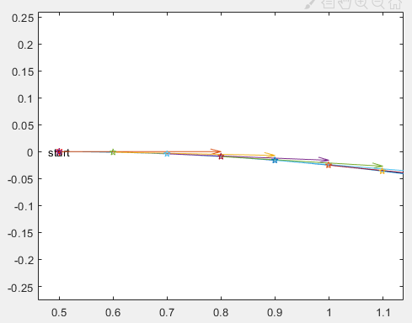
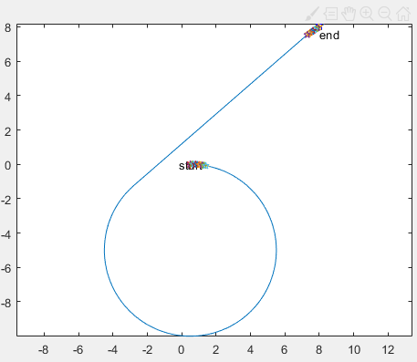
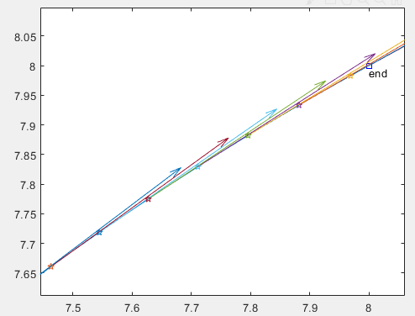

CPathServer 테스트

[ INFO] [1549949319.654510584]: TESTPATH
[ INFO] [1549949319.654535249]: LOOP
[ INFO] [1549949319.654548690]: start Pose : p: (0, 0) theta: 0
[ INFO] [1549949319.654554875]: end Pose : p: (1, 1) theta: 1
[ INFO] [1549949319.654560481]: LOOP
[ INFO] [1549949319.654565363]: start Pose : p: (1, 1) theta: 1
[ INFO] [1549949319.654570286]: end Pose : p: (2, 2) theta: 2
[ INFO] [1549949319.654574829]: LOOP
[ INFO] [1549949319.654579566]: start Pose : p: (2, 2) theta: 2
[ INFO] [1549949319.654584317]: end Pose : p: (3, 3) theta: 3
[ INFO] [1549949319.654589560]: ADDITIONALPATH
[ INFO] [1549949319.654594998]: start Pose : p: (3, 3) theta: 3
[ INFO] [1549949319.654600571]: end Pose : p: (4, 4) theta: 4
[ INFO] [1549949319.654617731]: ATTACHED PATH
[ INFO] [1549949319.654622428]: LOOP
[ INFO] [1549949319.654627610]: end Pose : p: (0, 0) theta: 0
[ INFO] [1549949319.654632706]: end Pose : p: (1, 1) theta: 1
[ INFO] [1549949319.654637009]: LOOP
[ INFO] [1549949319.654642141]: end Pose : p: (1, 1) theta: 1
[ INFO] [1549949319.654647142]: end Pose : p: (2, 2) theta: 2
[ INFO] [1549949319.654651210]: LOOP
[ INFO] [1549949319.654656029]: end Pose : p: (2, 2) theta: 2
[ INFO] [1549949319.654661505]: end Pose : p: (3, 3) theta: 3
[ INFO] [1549949319.654665376]: LOOP
[ INFO] [1549949319.654669557]: end Pose : p: (3, 3) theta: 3
[ INFO] [1549949319.654673878]: end Pose : p: (4, 4) theta: 4
[ INFO] [1549949319.654684926]: DETACHED PATH, POINT= 3rd
[ INFO] [1549949319.654689375]: LOOP
[ INFO] [1549949319.654694371]: end Pose : p: (1, 1) theta: 1
[ INFO] [1549949319.654699381]: end Pose : p: (2, 2) theta: 2
[ INFO] [1549949319.654702957]: LOOP
[ INFO] [1549949319.654707978]: end Pose : p: (2, 2) theta: 2
[ INFO] [1549949319.654713097]: end Pose : p: (3, 3) theta: 3
[ INFO] [1549949319.654717157]: LOOP
[ INFO] [1549949319.654722041]: end Pose : p: (3, 3) theta: 3
[ INFO] [1549949319.654727061]: end Pose : p: (4, 4) theta: 4
[ INFO] [1549949319.654734436]: CLEARING PATH
[ INFO] [1549949319.654739726]: NOTHING

DistanceCalculator 테스트

[ INFO] [1550211605.396710846]: Distance Between Segments : 2.828427
[ INFO] [1550211605.396734362]: distanceBetweenBackCarts : 0.500000
[ INFO] [1550211605.396742693]: distanceBetweenFrontCarts : 1.118034
[ INFO] [1550211605.396750305]: Distance: 4.446461

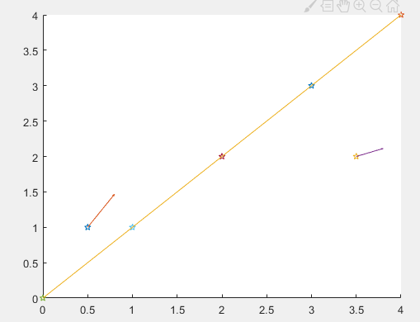

CoordinationConverter 테스트

double CCoordinationConverter::FRONT_CAM_OFFSET_X= 1;
double CCoordinationConverter::FRONT_CAM_OFFSET_Y= 0;
double CCoordinationConverter::REAR_CAM_OFFSET_X= -1;
double CCoordinationConverter::REAR_CAM_OFFSET_Y= 0;]

[ INFO] [1550217647.719255247]: Current Cart Global Pose : p: (0, 1) theta: 0.1
[ INFO] [1550217647.719289870]: Target Robot Pose : p: (1, 1) theta: 0.1
[ INFO] [1550217647.719316519]: Target Global Pose : p: (2.87524, 2.29351) theta: 0.2

PathAttacher : 앞 카트의 새로운 자세와 경로를 받아 연결할 경로를 반환하는 클래스
PathServer: 경로의 추가, 삭제, 초기화 등을 담당하는 클래스
DistanceCalculator : 앞 카트와 현 카트의 경로 상 거리를 계산하는 클래스
CoordinationConverter : 로봇 좌표계의 자세와 로봇의 절대 자세를 이용하여 타깃의 절대 자세를 구하는 클래스

20190215 김수민

다음 주 과제 : 문서화 및 인수인계

